


Module Code & Module Title
CC5061NI Applied Data Science

60% Individual Coursework
Submission : Milestone 1

Academic Semester: Spring Semester 2026

Credit: 15 credit Semester long module

Student Name: Naitik Joshi
London Met ID: 24046599
College ID: NP01AI4A240025
Assignment Due Date: Friday, April 3, 2026
Assignment Submission Date: Friday, April 3, 2026
Submitted To: Subarna Sapkota

I confirm that I understand my coursework needs to be submitted online via MST Classroom under the relevant module page before the deadline in order for my assignment to be accepted and marked. I am fully aware that late submissions will be treated as non-submission and a mark of zero will be awarded.
Table of Contents
1. Data Understanding 1
1.1 Dataset Overview 1
1.3 Identified Challenges 3
2. Data Preparation 4
2.1 Import the Dataset 4
2.2 Dataset Insight 4
3. Data Cleaning 5
3.1 Convert Age Group to Ordinal Categorical 6
3.2 Create Purchase_Value_Category Column 6
3.3 Drop Irrelevant Columns 7
3.4 Handle Missing Values 7
3.5 List Unique Values for Categorical Columns 8

Table of Figures
Figure 1: Importing Dataset 4
Figure 2: Showing data using .head(15) 4
Figure 3: df.info() showing datatypes 5
Figure 4: Age group convert code 6
Figure 5: Purchase value categorization 7
Figure 6: Dropping Irelevant columns 7
Figure 7: Handling missing values 8
Table of Tables
Table 1: Data Description Table 1
Table 2: Business Relevance 5

1. Data Understanding

1.1 Dataset Overview
Data understanding is the crucial first step in any data science lifecycle. It involves exploring the raw data to see its size, structure, and potential errors. This step is important because performing complex analysis on messy or misunderstood data will lead to incorrect business conclusions.
The dataset used for this project is the Diwali Sales Transaction Data. It is a transactional dataset from the retail and e-commerce domain. The overall goal of analyzing this data is to uncover hidden purchasing trends during the Diwali festival—such as which age group or region drives the most sales—so that the business can make data-driven marketing decisions.
1.2 Data Description Table
Table 1: Data Description Table
Column Name | Data Type | Description | Potential Issues
User_ID | Integer (int64) | Unique tracking number for each customer | Privacy concern; to be dropped
Cust_name | String (object) | Full name of the purchasing customer | Privacy concern; to be dropped
Product_ID | String (object) | Unique identification code for the item sold | None
Gender | String (object) | The gender of the customer (M/F) | None
Age Group | String (object) | Categorized age ranges (e.g., 26-35) | Needs grouping into ordinal categories
Age | Integer (int64) | The exact numerical age of the customer | Contains missing (NaN) values
Marital_Status | Integer (int64) | Binary indicator: 0 (Unmarried), 1 (Married) | None
State | String (object) | The state where the transaction occurred | None
Zone | String (object) | The broader geographic region | None
Occupation | String (object) | The professional sector of the customer | None
Product_Category | String (object) | The category classification of the item | None
Orders | Integer (int64) | Total number of items bought in one transaction | None
Amount | Float (float64) | Total money spent in the transaction | Crucial issue: contains missing values
Status | Float (float64) | Order tracking status | Completely empty (Null); useless
unnamed1 | Float (float64) | Empty column caused by data export errors | Artefact; to be dropped

1.3 Identified Challenges
Upon initial inspection, a few data quality challenges were identified. Firstly, there are missing values (NaN) in the crucial Amount and Age columns. Secondly, there are completely empty or irrelevant columns such as unnamed1 and Cust_name that add noise to the dataset. Finally, the raw data needs specific encoding to be read correctly into Python without throwing formatting errors.

2. Data Preparation

2.1 Import the Dataset
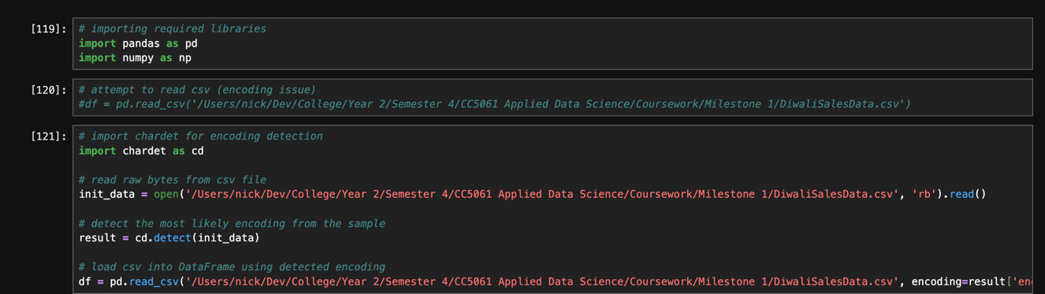
Figure 1: Importing Dataset
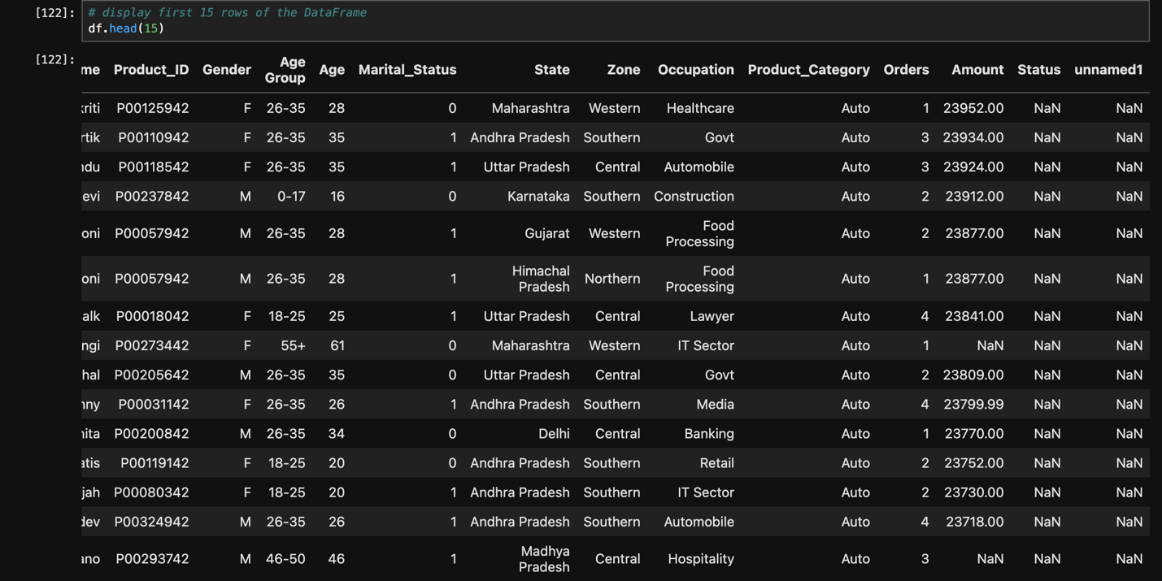
Figure 2: Showing data using .head(15)
Explanation:
The dataset was imported using the Pandas library. Because the CSV file contained different encoding style, it caused a standard import to fail. Hence, the chardet library was utilized. This automatically detected the correct encoding from the file's raw bytes and passed it into the pd.read_csv() function. The output of the first 15 rows confirms that the data was loaded successfully without any formatting errors.

2.2 Dataset Insight
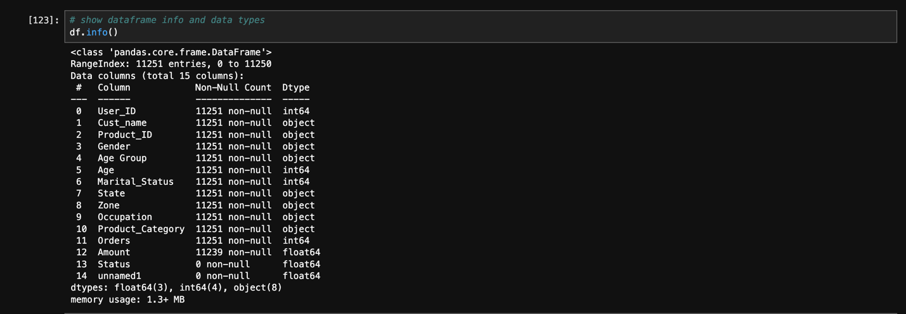
Figure 3: df.info() showing datatypes
Explanation:
The dataset's structure consists of integer (int64), decimal (float64), and text (object) data types. Understanding the business relevance of these columns is key to our analysis:
Table 2: Business Relevance
Column | Business Relevance
Amount | Reflects the total sales revenue generated per transaction. This is the primary measure of overall sales performance and customer spending power.
Orders | Indicates the volume of items purchased in one transaction. Higher order counts suggest bulk buying behavior.
Product_Category | Identifies which specific item types are driving the most revenue, which is essential for inventory and stock management.
Occupation | Allows the business to segment customers by professional field, revealing which industries yield the highest-spending demographics.

3. Data Cleaning

3.1 Convert Age Group to Ordinal Categorical
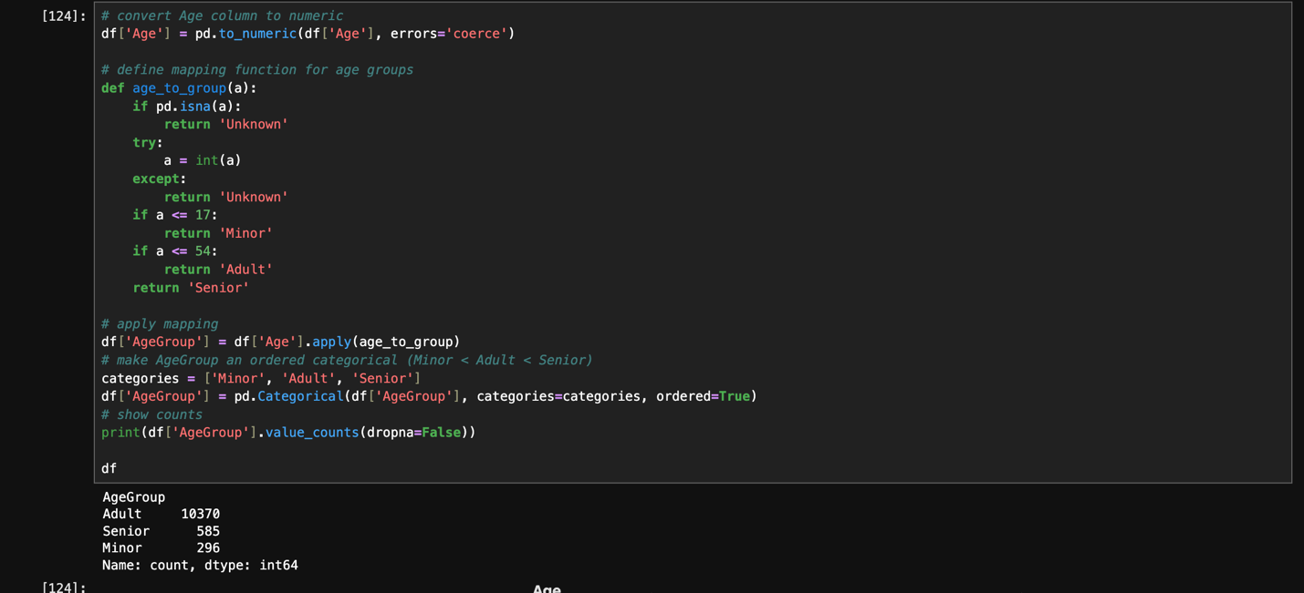
Figure 4: Age group convert code
Explanation:
To accurately analyze demographics, a custom mapping function was created to group numerical ages into life stages: Minor (17 and under), Adult (18 to 54), and Senior (55 and older). The pd.Categorical() function was then used with the parameter ordered=True. Ordinal encoding is vital because it preserves the meaningful sequence of these life stages (Minor < Adult < Senior), enabling logical and mathematical comparisons during analysis.

3.2 Create Purchase_Value_Category Column
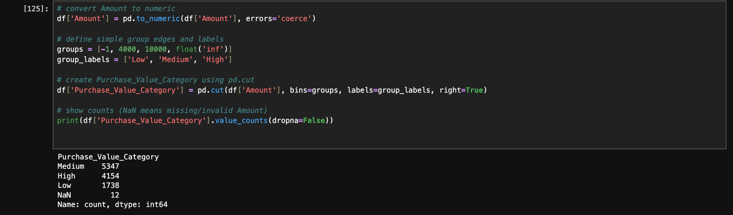
Figure 5: Purchase value categorization
Explanation:
To segment customers by their spending habits, a new column named Purchase_Value_Category was created. The pd.cut() function was utilized to partition the continuous Amount variable into discrete categories. The thresholds were defined as Low (0-4000), Medium (4001-10000), and High (10000+). This categorization simplifies high-level reporting on customer spending tiers.

3.3 Drop Irrelevant Columns
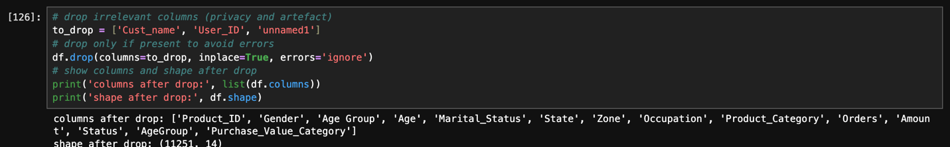
Figure 6: Dropping Irelevant columns
Explanation:
Irrelevant columns were removed to clean the dataset. Cust_name and User_ID contain personal identifiers that provide no statistical value for aggregate sales analysis, and dropping them maintains data privacy. The unnamed1 column was an empty artefact. Removing these variables reduces dimensionality and saves memory.

3.4 Handle Missing Values
Techniques for Handling Missing Values:
Data Scientists generally use a few techniques for missing data:
- Mean/Median Imputation: Replacing blanks with the average or middle value of the column.
- Mode Imputation: Replacing blanks with the most frequently occurring value (used for categorical data).
- Row Deletion (Dropping): Completely removing the row containing the missing data.
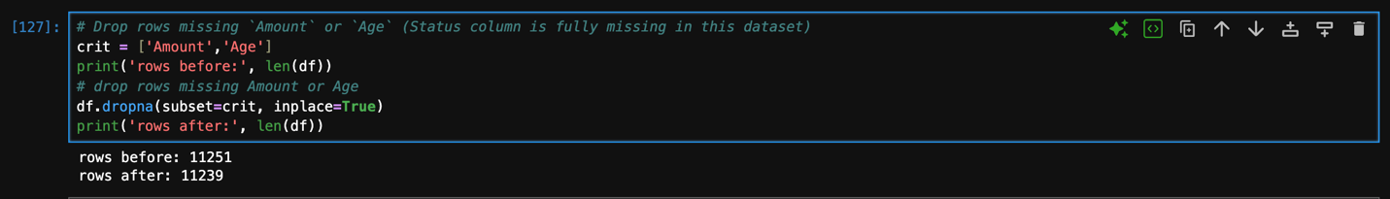
Figure 7: Handling missing values
Explanation:
A total of 12 rows contained null values in the critical Amount and Age fields. These rows were completely removed using the .dropna() method. Dropping these rows was chosen over imputing (guessing) the values because Amount is our primary outcome variable. Estimating financial sales figures would introduce statistical bias and compromise the integrity of our later analysis.

3.5 List Unique Values for Categorical Columns
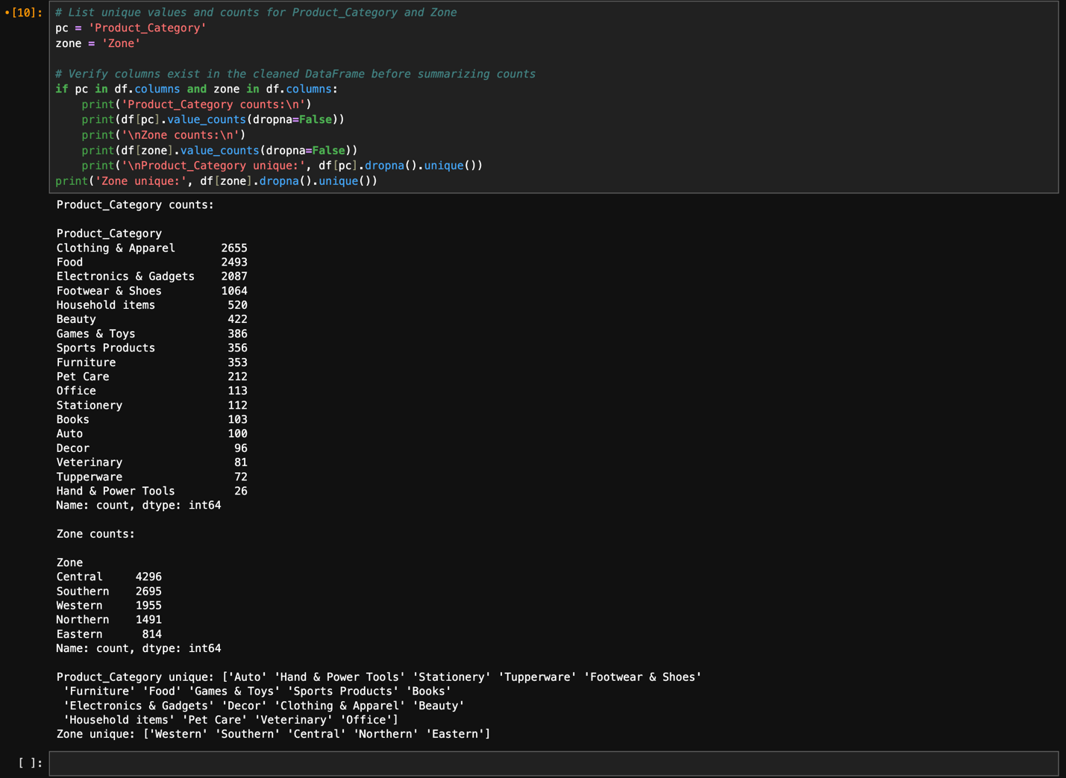
Explanation:
To fully grasp the categorical dimensions of the dataset, the unique() method was applied. The output confirmed that there are 5 unique geographic zones (Western, Southern, Central, Northern, Eastern) and 18 distinct product categories (including Auto, Food, Electronics & Gadgets, etc.). Verifying these unique values ensures there are no hidden dummy values or spelling errors before generating visual charts.

